Create Custom Pipes

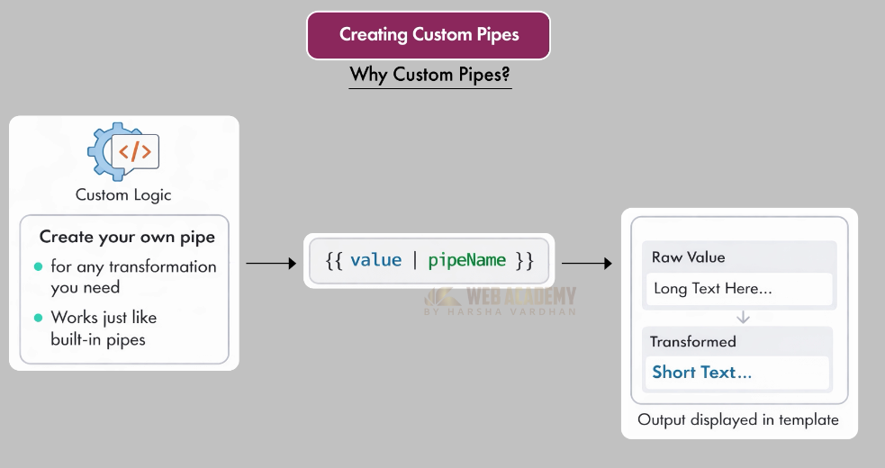

Command:

>> ng g pipe truncate

CREATE src/app/truncate-pipe.spec.ts (203 bytes)
CREATE src/app/truncate-pipe.ts (233 bytes)

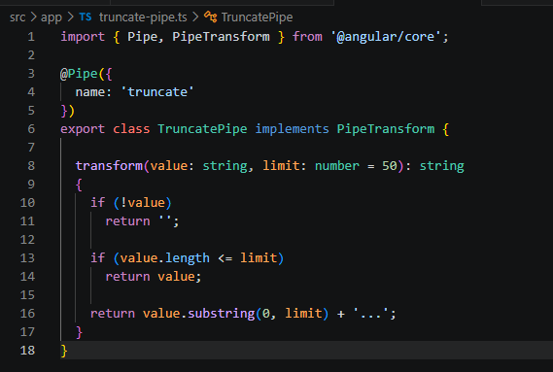

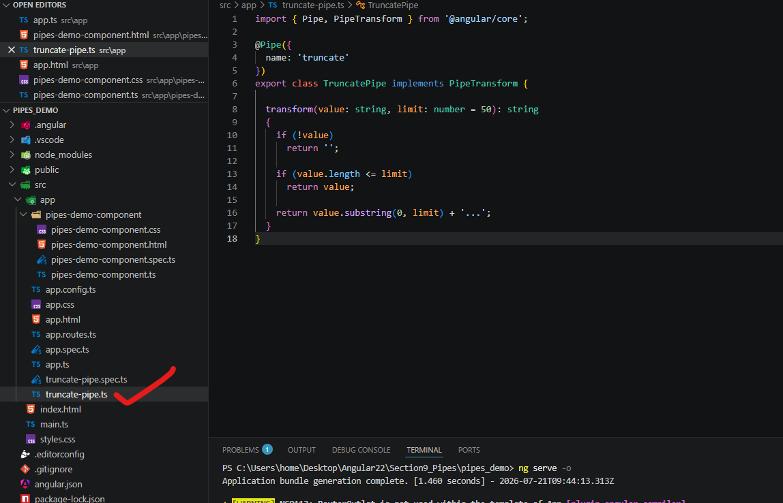
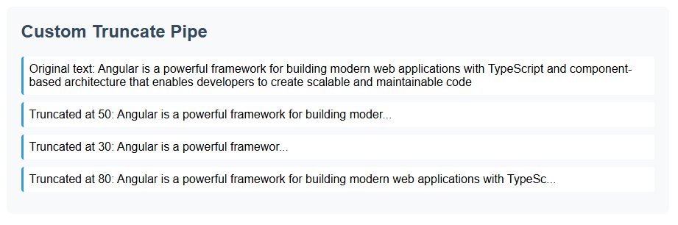

In the component that we want to use our custom pipes : we need to import it.
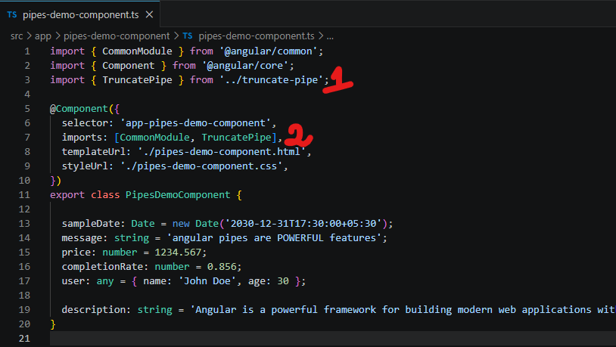

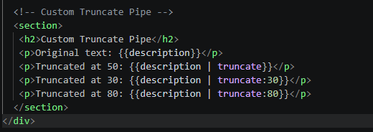

<!-- Custom Truncate Pipe -->
<section>
<h2>Custom Truncate Pipe</h2>
<p>Original text: {{description}}</p>
<p>Truncated at 50: {{description | truncate}}</p>
<p>Truncated at 30: {{description | truncate:30}}</p>
<p>Truncated at 80: {{description | truncate:80}}</p>
</section>

